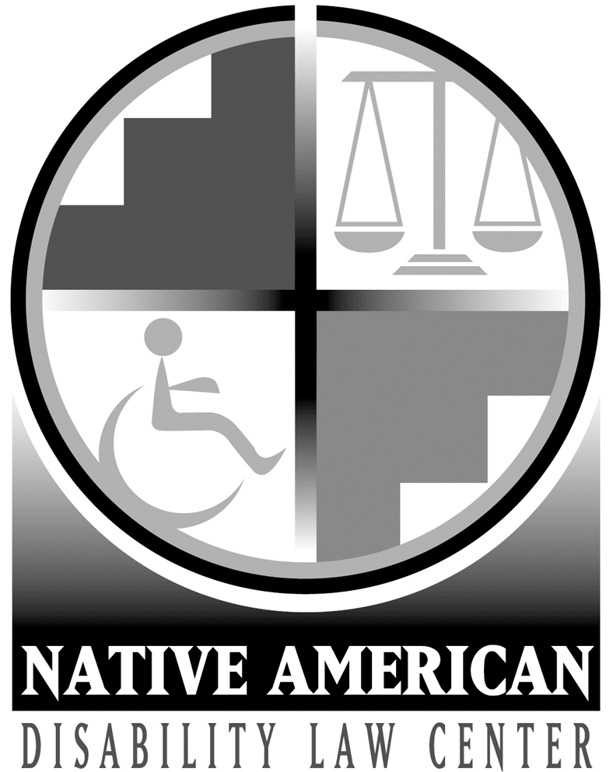
Statement of Priorities & Objectives
October 1, 2026 – September 30, 2027

REQUEST FOR PUBLIC COMMENT

The Native American Disability Law Center (the Law Center) is a non-profit organization that provides free legal services to Native Americans with disabilities. Every year the Law Center reviews its Statement of Objectives and Priorities to ensure that we are best serving the needs of our client community. We are seeking public comment before or by September 29, 2026. You can comment by calling us at 1-800-862-7271 or by emailing us at info@nativedisabilitylaw.org.
Thank you for your interest and support of the Law Center.

A - Intake & Outreach

Goal: Efficiently provide timely services to new clients & increase awareness of the Law Center’s services through community & media-based outreach, providing training & information.

Objective 1: Promoting Vocational Rehabilitation Services. Increase awareness of vocational rehabilitation services through developing & distributing public awareness information and materials.

Objective 2: Promote Self-Advocacy & Understanding of Rights. The Law Center will participate in local outreach events & three conferences or training events to increase:
- the understanding of Native Americans with disabilities & their families of their rights to services, supports, & employment;
- the ability of Native Americans with disabilities & their families to advocate for their needs & services;
- the understanding of the issues facing Native Americans with disabilities; &
- awareness of the Law Center & its services.

B - Children’s Education & Safety

Goal: All Native American children in the Four Corners region will have access to appropriate education & services designed to keep them safe & meet their unique needs in the least restrictive environment.

Objective 1: Promote Self-Advocacy. Provide technical assistance to families of twenty (20) students with disabilities to empower them to advocate for their children to obtain appropriate education and related services in the least restrictive environment.

Objective 2: Direct Representation. Provide direct representation in meetings, informal settings, and/or administrative proceedings to fifteen (15) children with disabilities who are not receiving a free appropriate public education in the least restrictive environment, with priority given to students who are excluded from school or who are not receiving appropriate transition services.

Objective 3: Systemic Advocacy. Through systemic advocacy, ensure that the federal & state education systems meet the educational needs of Native American students with disabilities enrolled in their schools.

C - Community Integration

Goal: Native Americans with disabilities will be free from abuse and neglect, whether they live in the community, residential facilities, or correctional institutions, & receive appropriate supports & services to enable them to live in the most integrated, least restrictive settings appropriate to their choices and needs.

Objective 1: Monitoring Facilities and Services. Monitor facilities and institutions at least every six (6) months & more frequently depending on the services provided & the needs of the residents. Monitoring will focus on instances of abuse and neglect, distributing educational materials, and providing advocacy services for individuals who are allegedly being abused or neglected.

Objective 2: Promote Civil Rights & Community Access. Provide direct assistance to individuals with disabilities in their efforts to protect & enforce their civil rights based on their disability & obtain appropriate community services, such as housing, voting, vocational rehabilitation services or employment.

Objective 3: Advocate for Improved Access to Services. Pursue three systemic initiatives to improve access to public services, prevent abuse & neglect, & improve services & access for Native Americans with disabilities.
.

